Activity 1: Episode 4

Episode 5:

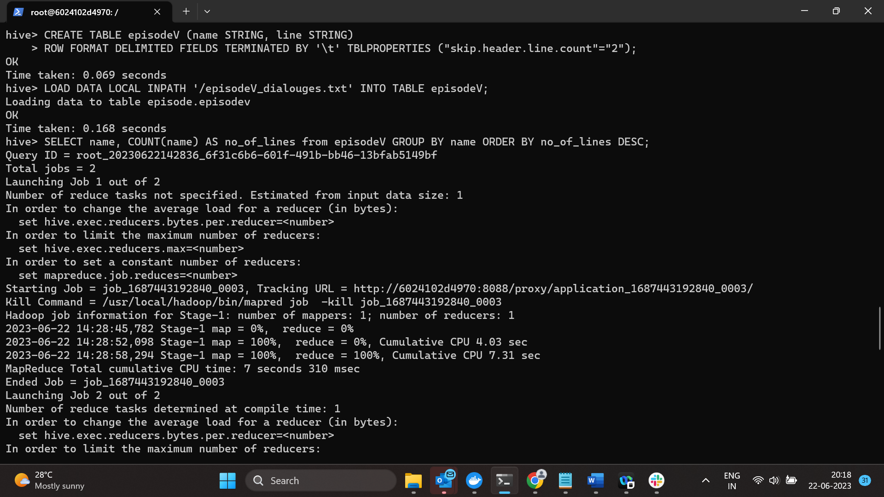

Episode 6:

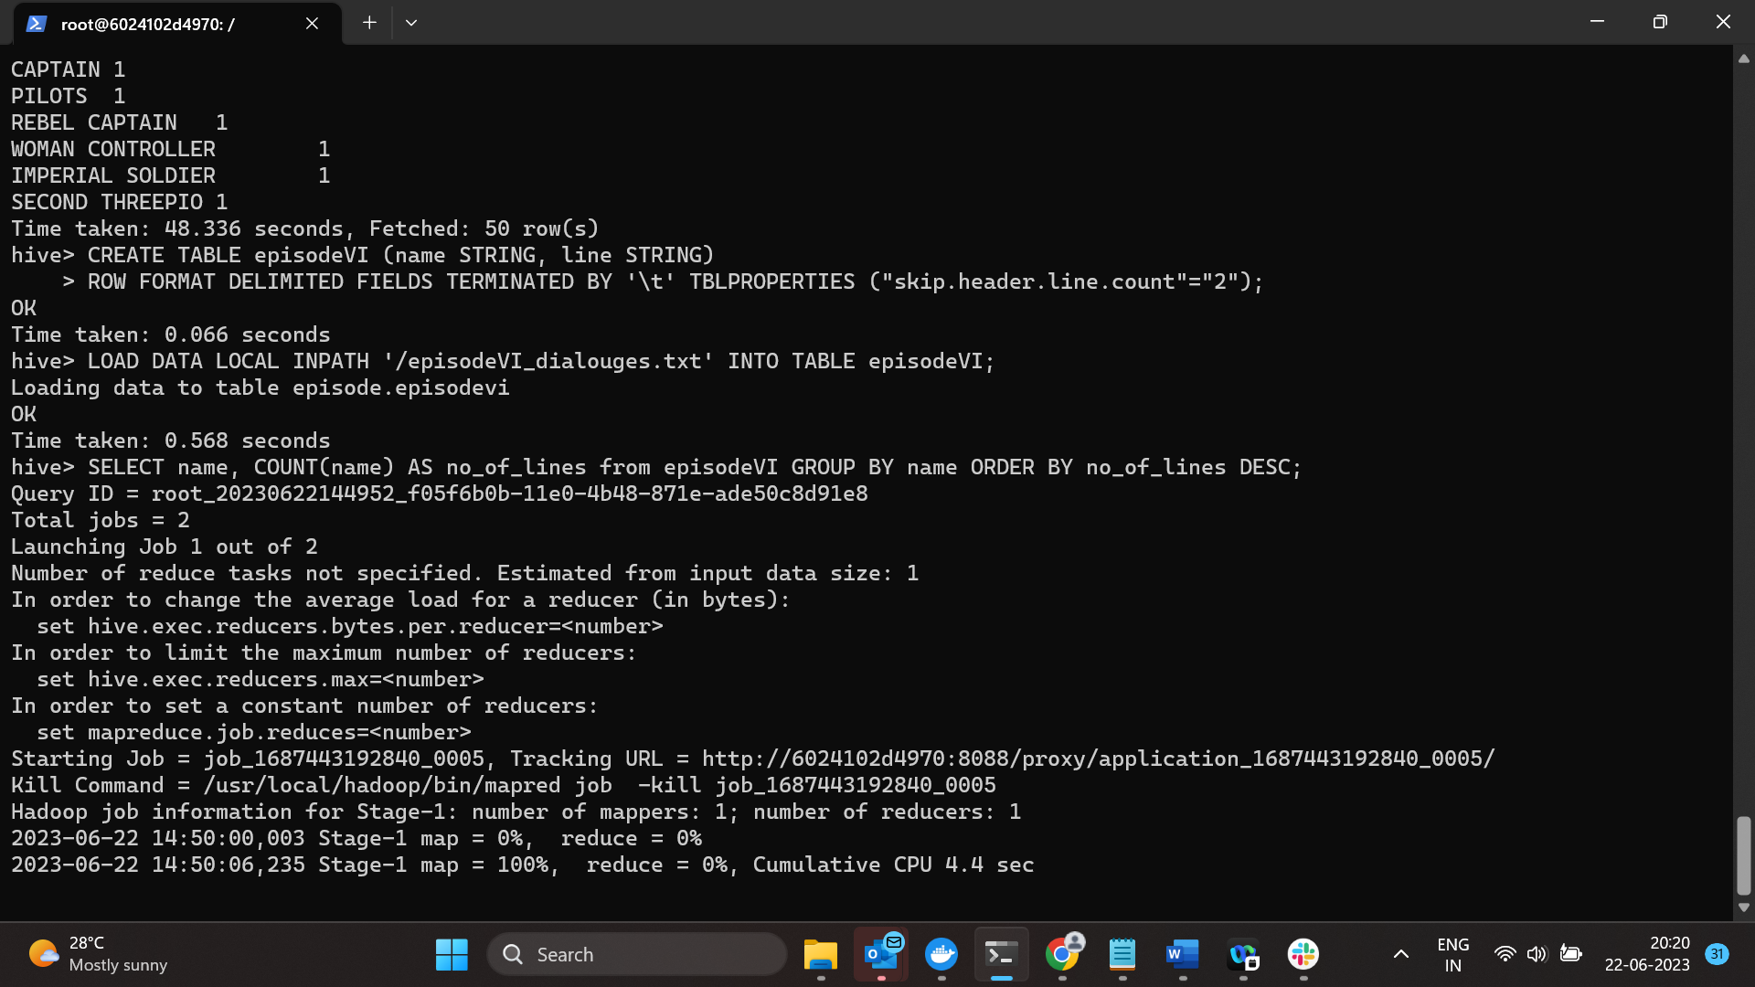

Activity 2:

